Indian E-Commerce Business Analysis Report

Executive Summary
This report presents a complete analysis of an Indian e-commerce dataset to identify sales trends, customer behavior, forecasting insights, and business opportunities. The analysis helps businesses improve decision-making related to inventory management, customer retention, marketing strategies, and future sales planning.

1. Introduction
The objective of this project was to analyze e-commerce sales and customer data to generate meaningful business insights. The project focused on:
- Sales trend analysis
- Product performance analysis
- Geographic sales analysis
- Customer segmentation using RFM analysis
- Future sales forecasting
- Business opportunity identification

2. Dataset Overview
The dataset contains:
- Customer information
- Product details
- Revenue data
- Geographic locations
- Customer transactions
- Product categories
- Purchase behavior information
The dataset was cleaned and processed before analysis.

3. Data Cleaning and Preprocessing
The following preprocessing steps were performed:
- Removed duplicate records
- Handled missing values
- Converted date columns into datetime format
- Standardized data formats
- Prepared cleaned datasets for analysis
The cleaned dataset was saved for further analysis and forecasting.

4. Sales Trend Analysis
Sales trend analysis was performed to understand monthly and yearly revenue behavior.
Key Findings
- Monthly sales fluctuations were identified.
- Seasonal sales trends were observed.
- Some periods generated significantly higher revenue.
- Overall sales trends showed business growth opportunities.
Visualizations Used

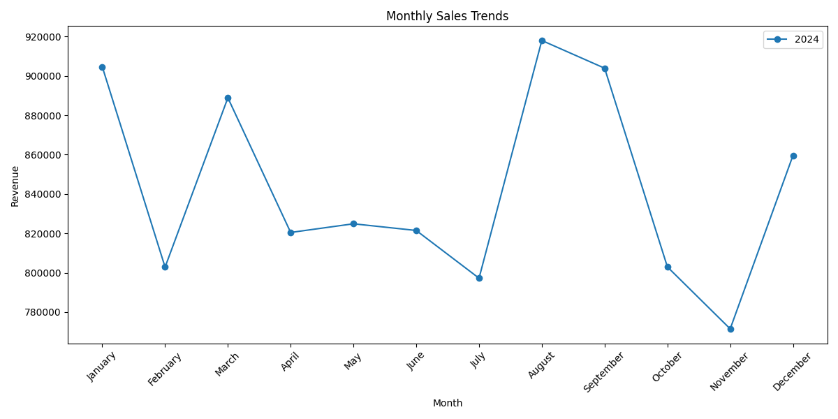
- Monthly Sales Trend Line Chart
- Monthly Sales Bar Chart
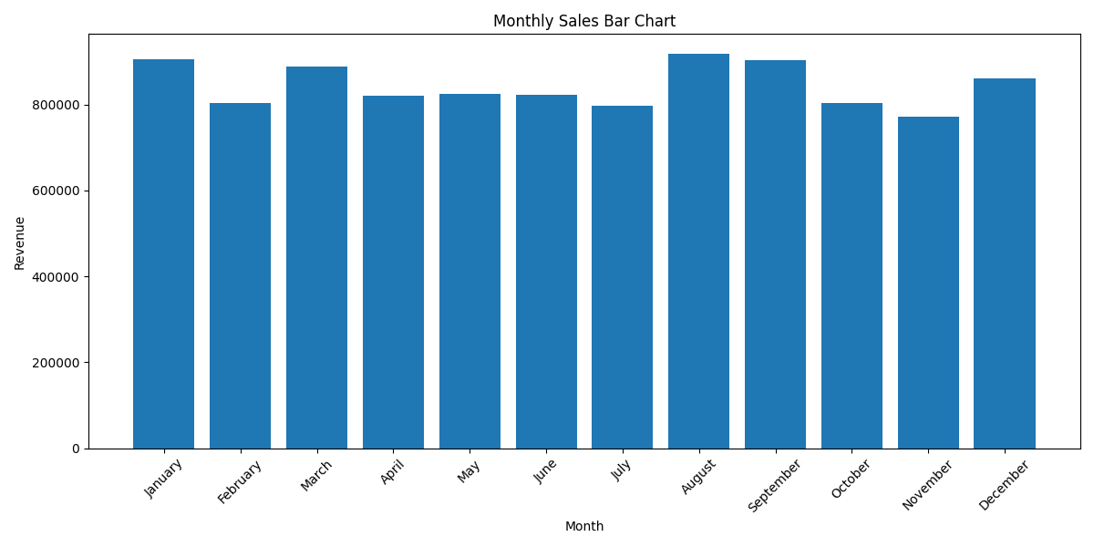
- Yearly Sales Analysis Chart
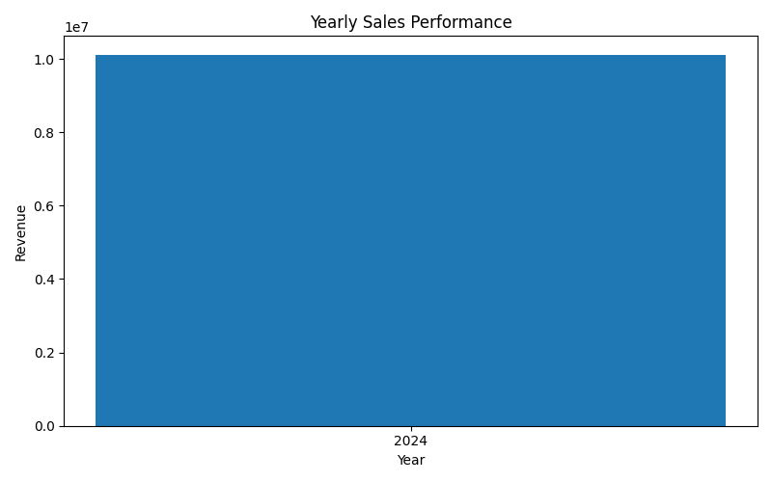

5. Best-Selling Products and Categories
Product-level and category-level analysis was performed to identify the most profitable products and categories.
Key Findings
- Certain product categories generated higher revenue consistently.
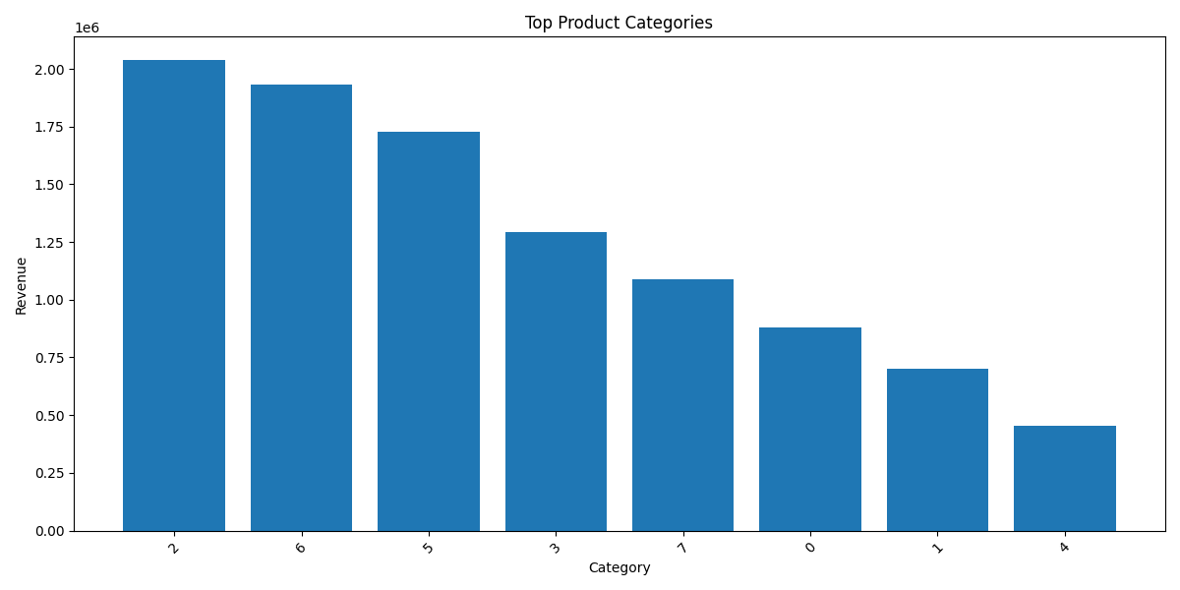
- Top-selling products contributed significantly to overall sales.
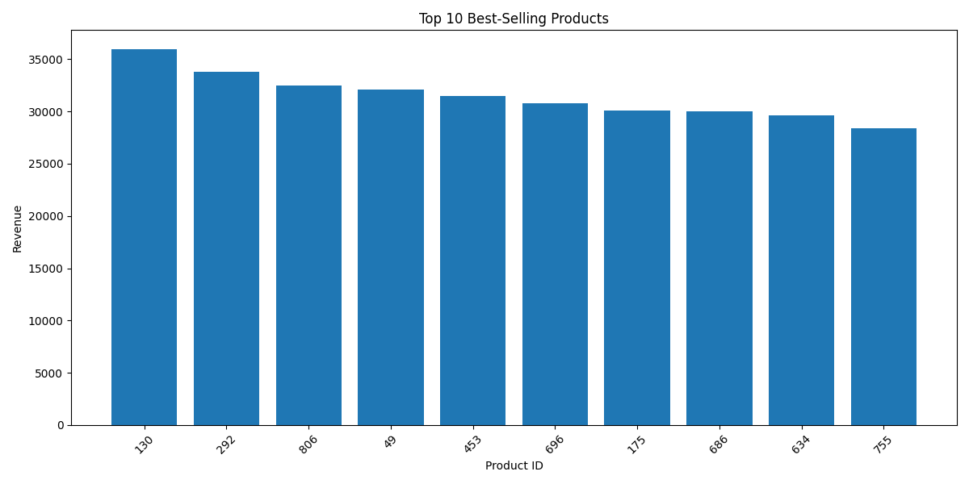
- Product demand varied across categories and seasons.
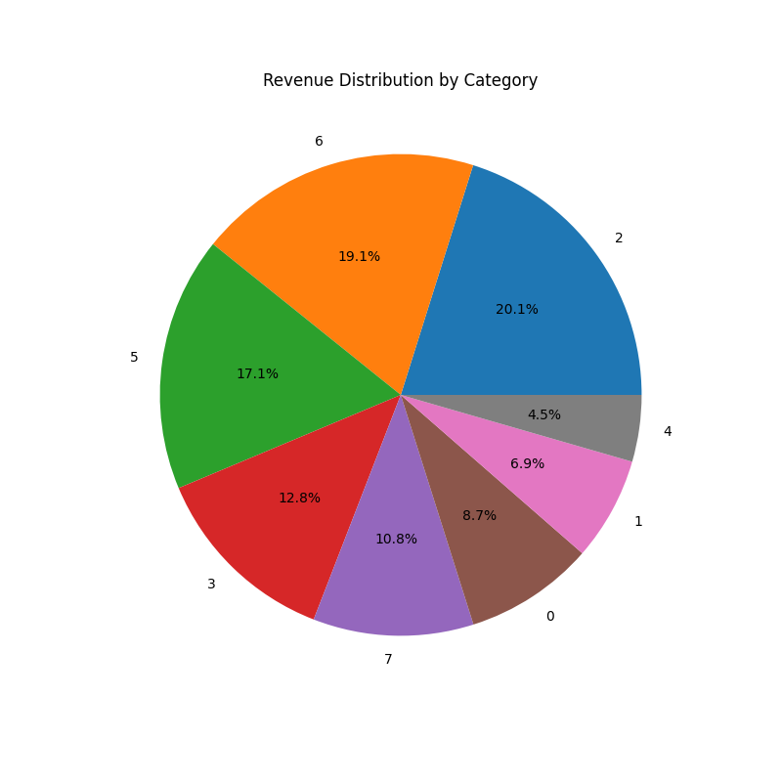
Business Insights
- High-performing products should receive inventory priority.
- Product bundling and promotional strategies can increase sales.

6. Geographic Sales Performance
Regional sales analysis was conducted to identify top-performing and low-performing locations.
Key Findings
- Some locations generated significantly higher revenue.
- Regional customer demand patterns were identified.
- Geographic trends support targeted marketing strategies.
Business Insights
- High-performing regions should receive increased marketing focus.
- Logistics and delivery improvements are required in low-performing regions.

7. Customer Segmentation Using RFM Analysis
Customers were segmented based on:
- Recency
- Frequency
- Monetary Value
Customer Segments Identified
- High-Value Customers
- Potential Loyalists
- Regular Customers
- At-Risk Customers
- Lost Customers
- New Customers
Key Findings
- High-value customers contribute major revenue.
- At-risk customers require re-engagement strategies.
- Loyal customers demonstrate strong purchasing behavior.

8. Customer Segment Visualization
Customer behavior was visualized using multiple charts and plots.
Visualizations Created
- Customer Segment Distribution Bar Chart
- Customer Segment Pie Chart
- RFM Heatmap
- Frequency vs Monetary Scatter Plot
Key Insights
- Customer groups differ significantly in spending behavior.
- Some customer segments require retention campaigns.
- High-value customer concentration was identified.

9. Time Series Data Preparation
Time series preparation was performed to structure sales data for forecasting.
Steps Performed
- Converted date columns into datetime format
- Aggregated daily sales revenue
- Handled missing dates
- Sorted data chronologically
- Created forecast-ready datasets
Key Findings
- Seasonal trends were identified.
- Revenue fluctuations were visible across time periods.

10. Sales Forecasting
Future sales forecasting was performed using the Holt-Winters Exponential Smoothing model.
Forecasting Process
- Prepared time series dataset
- Split data into training and testing sets
- Trained forecasting model
- Generated future sales predictions
- Evaluated model accuracy
Forecast Accuracy
RMSE Value:
9398.510203948661
Key Findings
- Future sales trends were successfully predicted.
- Forecasting identified future revenue fluctuations.
- Seasonal demand patterns influenced predictions.
Business Insights
- Forecasting supports inventory planning.
- Businesses can prepare for high-demand periods.
- Marketing strategies can be aligned with expected sales trends.

11. Business Opportunity Analysis
Business opportunity analysis identified several growth areas and strategic opportunities.
Key Opportunities
- Expansion of high-growth product categories
- Regional sales growth opportunities
- Personalized marketing strategies
- Upselling and cross-selling opportunities
- Customer loyalty and retention programs
Recommendations
- Increase inventory for top-selling categories
- Focus marketing efforts in high-performing regions
- Launch customer loyalty programs
- Implement targeted promotional campaigns
- Re-engage at-risk customers

12. Business Recommendations
Inventory Optimization
Increase stock levels for high-demand products and forecasted peak periods.
Regional Marketing
Focus marketing campaigns on high-performing locations.
Customer Retention
Develop loyalty programs and personalized offers for valuable customers.
Promotional Strategies
Use seasonal promotions and discounts during low-sales periods.
Forecast-Based Planning
Use sales forecasting insights for pricing and operational planning.

13. Conclusion
The project successfully analyzed:
- Sales trends
- Product performance
- Geographic sales distribution
- Customer behavior
- Future sales forecasting
- Business opportunities
The analysis generated valuable insights that can help businesses improve:
- Revenue growth
- Customer retention
- Marketing efficiency
- Inventory planning
- Strategic decision-making
The project demonstrates how data analytics can support business intelligence and improve operational efficiency in e-commerce businesses.

14. Technologies Used
- Python
- Pandas
- NumPy
- Matplotlib
- Scikit-Learn
- Statsmodels

15. Final Outcome
The project successfully transformed raw e-commerce data into meaningful business insights and actionable recommendations that support future business growth, customer engagement, and sales optimization.

